PRACTICAL NO. 3

mysql>create database TE;
Query OK, 1 row affected (0.02 sec)

mysql> USE TE;
Database changed
mysql> CREATE TABLE B4(NAME VARCHAR(20),ROLL_NO INT );
Query OK, 0 rows affected (0.04 sec)

mysql> INSERT INTO B4 VALUES("NIHAR",74);
Query OK, 1 row affected (0.03 sec)

mysql> INSERT INTO B4 VALUES("SUYOG",75);
Query OK, 1 row affected (0.02 sec)

mysql> INSERT INTO B4 VALUES("SANIKA",71);
Query OK, 1 row affected (0.03 sec)

mysql> INSERT INTO B4 VALUES("AKANKSHA",72);
Query OK, 1 row affected (0.03 sec)

mysql> INSERT INTO B4 VALUES("SAKSHI B.",73);
Query OK, 1 row affected (0.03 sec)

mysql> INSERT INTO B4 VALUES("SAKSHI D.",76);
Query OK, 1 row affected (0.01 sec)

mysql> INSERT INTO B4 VALUES("SAMIKSHA",77);
Query OK, 1 row affected (0.03 sec)

mysql> INSERT INTO B4 VALUES("YADNESH",78);
Query OK, 1 row affected (0.00 sec)

mysql> INSERT INTO B4 VALUES("SHITAL",79);
Query OK, 1 row affected (0.00 sec)

mysql> INSERT INTO B4 VALUES("DNYANESH",81);
Query OK, 1 row affected (0.02 sec)

mysql> INSERT INTO B4 VALUES("VRUSHALI D.",82);
Query OK, 1 row affected (0.01 sec)

mysql> INSERT INTO B4 VALUES("VRUSHALI P.",83);
Query OK, 1 row affected (0.02 sec)

mysql> INSERT INTO B4 VALUES("RUPALI",84);
Query OK, 1 row affected (0.03 sec)

mysql> INSERT INTO B4 VALUES("KETAN",85);
Query OK, 1 row affected (0.02 sec)

mysql> INSERT INTO B4 VALUES("OMKAR",86);
Query OK, 1 row affected (0.02 sec)

mysql> INSERT INTO B4 VALUES("PRATIK",87);
Query OK, 1 row affected (0.03 sec)

mysql> INSERT INTO B4 VALUES("KUSHAL",80);
Query OK, 1 row affected (0.02 sec)

mysql> SELECT * FROM B4;

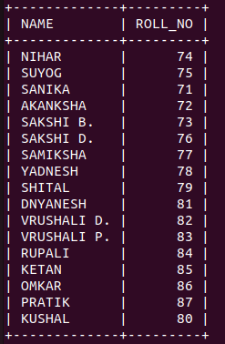

7 rows in set (0.00 sec)

mysql> UPDATE B4 SET ROLL_NO=88 WHERE NAME="KUSHAL";
Query OK, 1 row affected (0.02 sec)
Rows matched: 1 Changed: 1 Warnings: 0

mysql> SELECT * FROM B4;

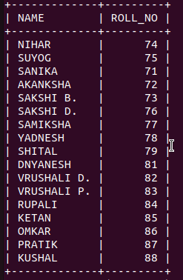

7 rows in set (0.00 sec)

mysql> SELECT * FROM B4 ORDER BY ROLL_NO ASC;

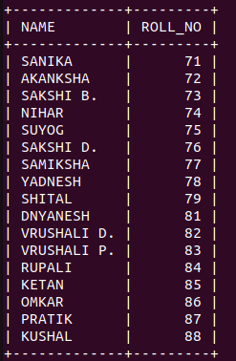

17 rows in set (0.00 sec)

mysql> ALTER TABLE B4 ADD ATTENDANCE VARCHAR(1);
Query OK, 0 rows affected (0.03 sec)
Records: 0 Duplicates: 0 Warnings: 0

mysql> UPDATE B4 SET ATTENDANCE="P";
Query OK, 17 rows affected (0.03 sec)
Rows matched: 17 Changed: 17 Warnings: 0

mysql> SELECT * FROM B4 ORDER BY ROLL_NO ASC;
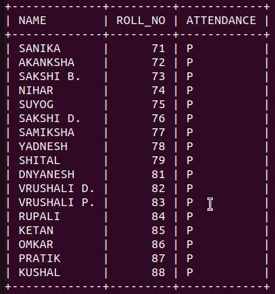

17 rows in set (0.00 sec)

mysql> INSERT INTO B4 VALUES("PALAK",80);
ERROR 1136 (21S01): Column count doesn't match value count at row 1
mysql> INSERT INTO B4 VALUES("PALAK",80,"A");
Query OK, 1 row affected (0.02 sec)

mysql> SELECT * FROM B4 ORDER BY ROLL_NO ASC;
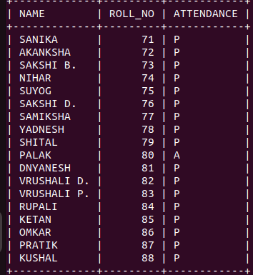

18 rows in set (0.00 sec)

mysql> ALTER TABLE B4 ADD PRIMARY KEY(ROLL_NO);
Query OK, 0 rows affected (0.06 sec)
Records: 0 Duplicates: 0 Warnings: 0

mysql> INSERT INTO B4 VALUES("DINESH",74,"A");
ERROR 1062 (23000): Duplicate entry '74' for key 'B4.PRIMARY'

mysql> DESC B4;
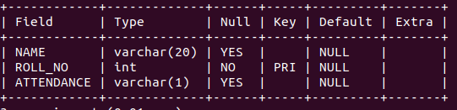
3 rows in set (0.01 sec)

mysql>

